Assignment 1: Overfitting and Underfitting with Neural Networks
CSC 592: Machine Learning Security and Privacy

Background

In machine learning, understanding underfitting and overfitting is important for building machine learning models that perform well on new (unseen) data. Underfitting occurs when a model is too simple to capture the underlying patterns in the data, leading to poor performance on both training and test sets. On the other hand, overfitting occurs when a model memorizes the training data rather than the true patterns in the data. Overfitting occurs due to over training which results in excellent performance on training data but poor performance to the test set. Overfitting is common when models are too complex relative to the amount of training data available. To achieve an optimal balance, techniques like regularization are used to ensure the model does not overfit.
In this lab, you will create an object-oriented implementation of a deep linear network (from scratch) using the provided starter code. You will then experiment with model complexity to see the effects of underfitting and overfitting when training a machine learning model.
Step by Step Guide
1. Create a Python application called NNDecisionBoundary. Add a file called Utils.py with the following code in it.

import numpy as np
from sklearn import datasets, linear_model
import matplotlib.pyplot as plt

class Utils(object):
def init_data(self):
# generate a random dataset and plot it
np.random.seed(0)
X, y = datasets.make_moons(200, noise=0.20)
plt.scatter(X[:,0], X[:,1], s=40, c=y, cmap=plt.cm.Spectral)
plt.show()
return X, y

def normalize_data(self,X):
min = np.min(X, axis = 0)
max = np.max(X, axis = 0)
normX = 1 - ((max - X)/(max-min))
return normX

2. Add a class called ActivationType.py with the following code in it:

class ActivationType(object):
NONE = 0
SIGMOID = 1
TANH = 2
RELU = 3
SOFTMAX = 4

3. Add a class called GradDescType.py with the following code in it:

class GradDescType(object):
STOCHASTIC = 1
BATCH = 2
MINIBATCH = 3

4. Add a class called Layer.py with the following code in it. This class contains the neurons, their activation functions, biases, and weights for a single layer in the neural network. Examine the code carefully to see how a single layer in a neural network is put together. The forward function does the forward pass through the layer.
import numpy as np
from ActivationType import ActivationType

class Layer(object): # represents one layer of neurons in an NN
def __init__(self,num_neurons,num_neurons_prev_layer, last_layer= False,drop_out = 0.2,activation_type=ActivationType.SIGMOID):
self.num_neurons = num_neurons
self.last_layer = last_layer
self.numNeurons_pre_Layer = num_neurons_prev_layer
self.activation_function = activation_type
self.drop_out = drop_out
self.delta = np.zeros((num_neurons,1))
self.a = np.zeros((num_neurons,1)) # actual output from layer
self.derivAF = np.zeros((num_neurons,1)) # derivative of Activation function
self.W = np.random.randn(num_neurons, num_neurons_prev_layer)/ np.sqrt(num_neurons_prev_layer) # initialize weight matrix randomly
self.b = np.zeros((num_neurons,1))
self.WGrad = np.zeros((num_neurons,num_neurons_prev_layer))
self.bGrad = np.zeros((num_neurons,1)) # gradient for biases

def forward(self,input_data):
sum = np.dot(self.W,input_data) + self.b
aa = 0
if (self.activation_function == ActivationType.NONE):
self.a = sum
self.derivAF = 1
if (self.activation_function == ActivationType.SIGMOID):
self.a = self.sigmoid(sum)
self.derivAF = self.a * (1 - self.a)
if (self.activation_function == ActivationType.TANH):
self.a = self.TanH(sum)
self.derivAF = (1 - self.a*self.a)
if (self.activation_function == ActivationType.RELU):
self.a = self.Relu(sum)
self.derivAF = 1.0 * (self.a > 0)
if (self.activation_function == ActivationType.SOFTMAX):
self.a = self.Softmax(sum)
self.derivAF = None # we do delta computation in Softmax layer
if (self.last_layer == False):
zeroout = np.random.binomial(1,self.drop_out,(self.num_neurons,1))/self.drop_out
# which neurons to zero out
self.a = self.a * zeroout
self.derivAF = self.derivAF * zeroout
return self.a

def Linear(self,x):
return x # output same as input

def sigmoid(self,x):
return 1 / (1 + np.exp(-x)) # np.exp makes it operate on entire array

def TanH(self, x):
return np.tanh(x)

def Relu(self, x):
return np.maximum(0,x)

def Softmax(self, x):
ex = np.exp(x)
return ex/ex.sum()

def clear_WBgradients(self): # zero out weight and bias gradients
self.WGrad = 0
self.bGrad = 0

5. Add a class called Network to the project with the following code in it. The Network class assembles the layers and provides the train forward function. The forward function passes the data through all the layers.

import math
import numpy as np
from Layer import *
from GradDescType import *
from sklearn.utils import shuffle

class Network(object):
def __init__(self,X,Y,num_layers,drop_out = 0.0, activationF=ActivationType.SIGMOID,last_layerAF= ActivationType.SOFTMAX):
self.X = X
self.Y = Y
self.num_layers = num_layers
self.Layers = [] # network contains list of layers
self.last_layerAF = last_layerAF
for i in range(len(num_layers)):
if (i == 0): # first layer
layer = Layer(num_layers[i],X.shape[1],False,drop_out, activationF)
elif (i == len(num_layers)-1): # last layer
layer = Layer(Y.shape[1],num_layers[i-1],True,drop_out, last_layerAF)
else: # intermediate layers
layer = Layer(num_layers[i],num_layers[i-1],False,drop_out, activationF)
self.Layers.append(layer)

def forward(self,input_data): # evaluates all layers
out_layer = self.Layers[0].forward(input_data)
for i in range(1,len(self.num_layers)):
out_layer = self.Layers[i].forward(out_layer)
return out_layer

def Train(self, epochs,learningRate, lambda1, gradDescType, batchSize=1):
for j in range(epochs):
loss = 0
self.X, self.Y = shuffle(self.X, self.Y, random_state=0)
zz = self.X.shape[0]
for i in range(self.X.shape[0]):
aout = self.forward(self.X[i]) # actual output of network
if (self.last_layerAF == ActivationType.SOFTMAX):
loss += -(self.Y[i] * np.log(aout)).sum()
else:
loss += ((aout - self.Y[i]) * \
(aout - self.Y[i])).sum()
lnum = len(self.num_layers)-1 # last layer number
# compute deltas, grads on all layers
while(lnum >= 0):
if (lnum == len(self.num_layers)-1): # last layer
if (self.last_layerAF == ActivationType.SOFTMAX):
self.Layers[lnum].delta = -self.Y[i]+ self.Layers[lnum].a
else:
self.Layers[lnum].delta = -(self.Y[i]-self.Layers[lnum].a) * self.Layers[lnum].derivAF
else: # intermediate layer
self.Layers[lnum].delta = np.dot(self.Layers[lnum+1].W.T,self.Layers[lnum+1].delta) * self.Layers[lnum].derivAF
if (lnum > 0): #previous output
prevOut = self.Layers[lnum-1].a
else:
prevOut = self.X[i]

self.Layers[lnum].WGrad += np.dot(self.Layers[lnum].delta,prevOut.T)
self.Layers[lnum].bGrad += self.Layers[lnum].delta
lnum = lnum - 1

if (gradDescType == GradDescType.MINIBATCH):
if (i % batchSize == 0):
self.UpdateGradsBiases(learningRate,lambda1, batchSize)

if (gradDescType == GradDescType.STOCHASTIC):
self.UpdateGradsBiases(learningRate,lambda1, 1)

if (gradDescType == GradDescType.BATCH):
self.UpdateGradsBiases(learningRate,lambda1, self.X.shape[0])

print("Iter = " + str(j) + " Loss = "+ str(loss))

def UpdateGradsBiases(self, learningRate, lambda1, batchSize):
# update weights and biases for all layers
for ln in range(len(self.num_layers)):
self.Layers[ln].W = self.Layers[ln].W - learningRate * (1/batchSize) * self.Layers[ln].WGrad
- learningRate * lambda1 * self.Layers[ln].W
self.Layers[ln].b = self.Layers[ln].b - learningRate * (1/batchSize) * self.Layers[ln].bGrad
self.Layers[ln].clear_WBgradients()

6. The main code will be in NNDecisionBoundary.py. Type the following code in it:

import sys
from Network import Network
from GradDescType import *
from ActivationType import *
from Utils import Utils
import numpy as np
import matplotlib.pyplot as plt

def plot_decision_boundary(pred_func, X, y):
# Set min and max values and give it some padding
x_min, x_max = X[:, 0].min() - .5, X[:, 0].max() + .5
y_min, y_max = X[:, 1].min() - .5, X[:, 1].max() + .5
h = 0.01
# Generate a grid of points with distance h between them
xx, yy = np.meshgrid(np.arange(x_min, x_max, h), np.arange(y_min, y_max, h))
# Predict the function value for the whole gid
xdata = np.c_[xx.ravel(), yy.ravel()]
xdatanp = xdata.reshape(xdata.shape[0],xdata.shape[1],1)
#print(xdatanp.shape)
Z = [pred_func(xdatanp[x]) for x in range(0,len(xdatanp))]
Z = np.array(Z)
exp_scores = np.exp(Z)
probs = exp_scores / np.sum(exp_scores, axis=1, keepdims=True)
Z = np.argmax(probs, axis=1)
Z = Z.reshape(xx.shape)
# Plot the contour and training examples
plt.contourf(xx, yy, Z, cmap=plt.cm.Spectral)
plt.scatter(X[:, 0], X[:, 1], c=y, cmap=plt.cm.Spectral)
plt.show()

def main():
utils = Utils()
X, Y = utils.init_data() # initialize data
#X = utils.normalizeData(X)
trainX = X.reshape((X.shape[0],X.shape[1],1))
trainY = np.zeros((len(Y),2))
for i in range(0,len(Y)):
if Y[i] == 1:
trainY[i,0] = 1
trainY[i,1] = 0
else:
trainY[i,0] = 0
trainY[i,1]= 1
trainY = trainY.reshape((X.shape[0],X.shape[1],1))
numLayers = [30,2]
NN = Network(trainX,trainY,numLayers,1.0,ActivationType.TANH, ActivationType.SOFTMAX) # try different activation functions
NN.Train(1000,0.10,0.0, GradDescType.MINIBATCH,1)

#------------ compute accuracy----------
accuracy = 0
for i in range(len(trainX)):
pred = NN.forward(trainX[i])
if (pred.argmax() == 0 and trainY[i,0,0] == 1) or \
(pred.argmax() == 1 and trainY[i,0,0] == 0):
accuracy = accuracy + 1
accuracy_percent = accuracy/len(trainX)
print('accuracy =', accuracy_percent)
plot_decision_boundary(lambda x: NN.forward(x), X, Y)

if __name__ == "__main__":
sys.exit(int(main() or 0))

As you can see from the above code, the main function creates a network and specifies the neurons via a list called numLayers. For example, the above code sets the number of neurons to 30 in the first layer, and 2 in the last layer. For the moon dataset, the input and output is two dimensional so that we can visualize the decision boundaries.

For this assignment, your goal is to understand the effect of number of layers, number of neurons in the hidden layers, different activation types, effect of stochastic vs minibatch, and overfitting, underfitting of the model.

Exercises
Exercise 1: Set the number of neurons in the hidden layer of the network to be 1. Train the network. Take a screenshot of the figure for submission. Answer the following question: based on the figure, is this model overfitting, underfitting or just right for the data? Hint: the code output should look similar to what is shown below.
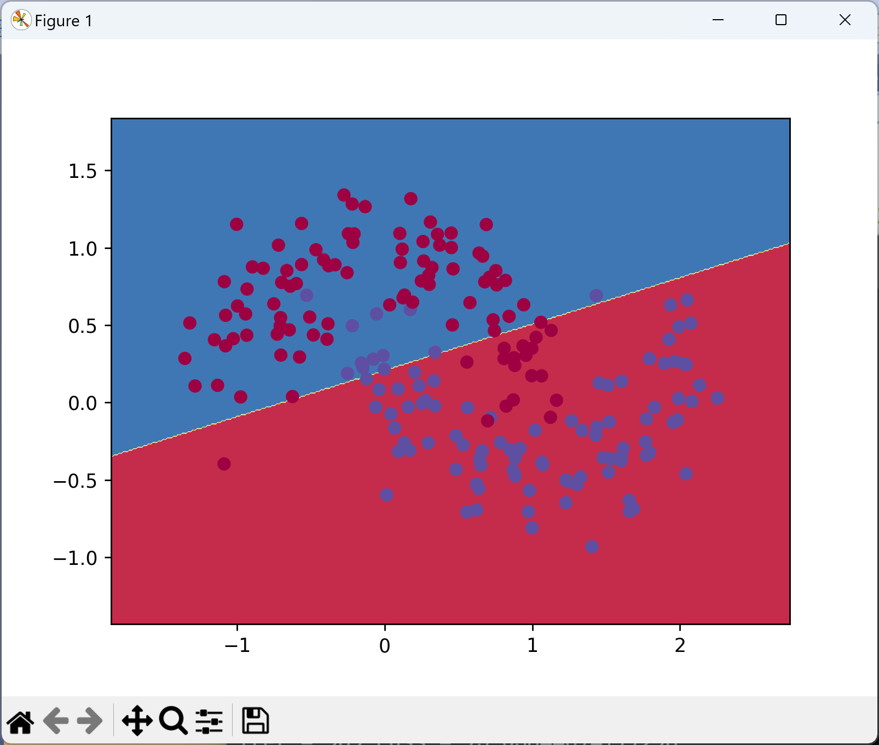
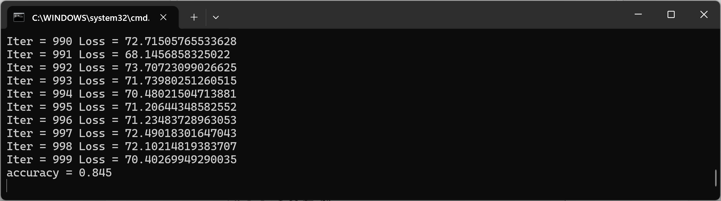

Exercise 2: Set the number of neurons in the hidden layer of the network to be 3. Train the network. Take a screenshot of the figure for submission. Answer the following question: based on the figure, is this model overfitting, underfitting or just right for the data? Hint: the code output should look similar to what is shown below.
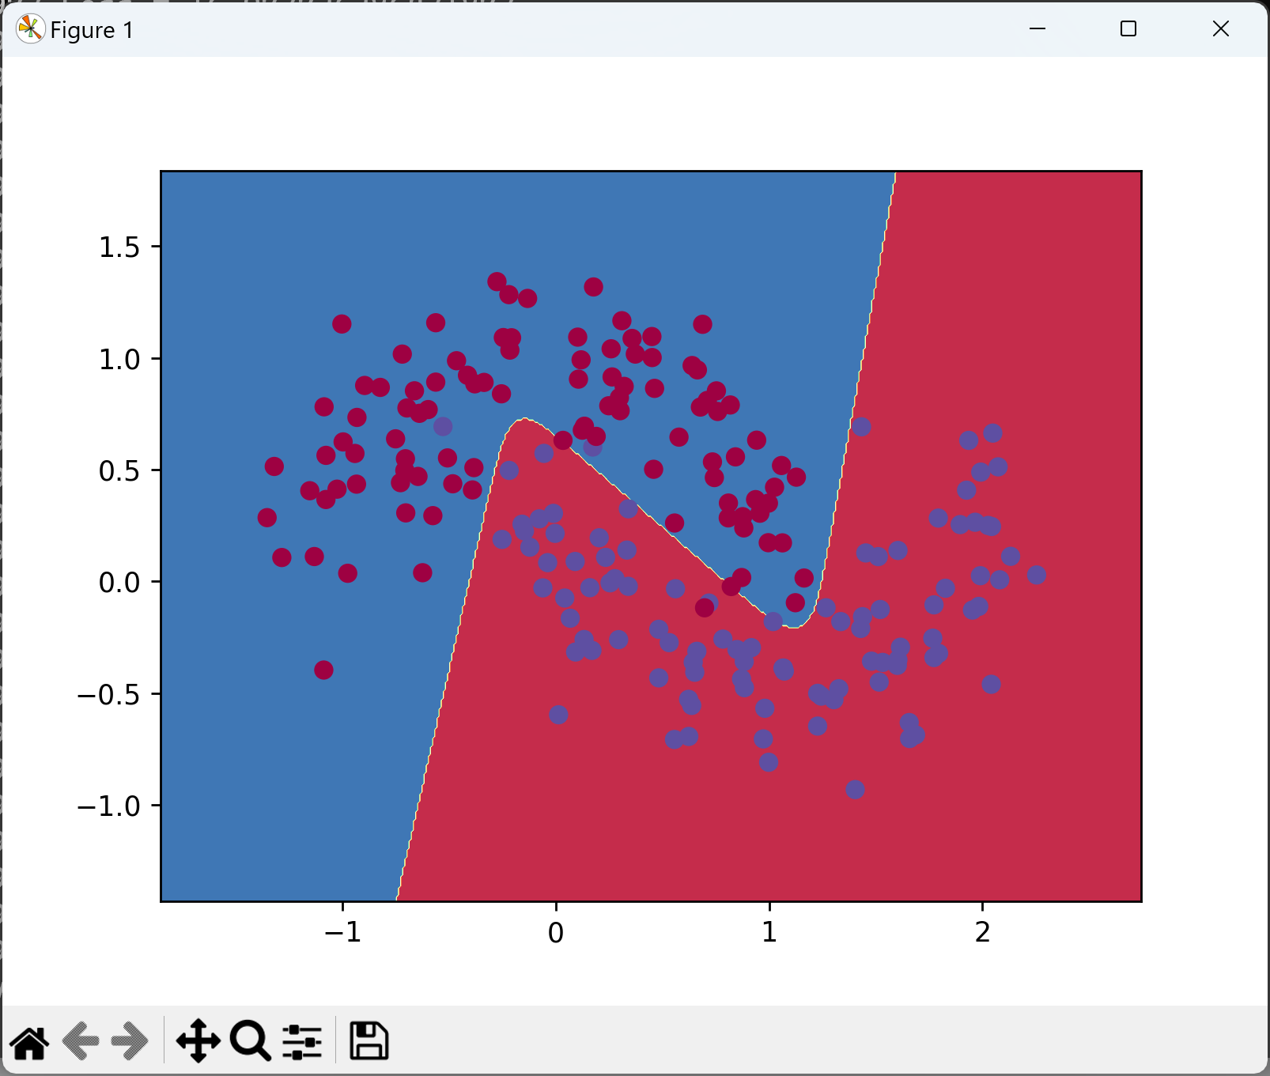
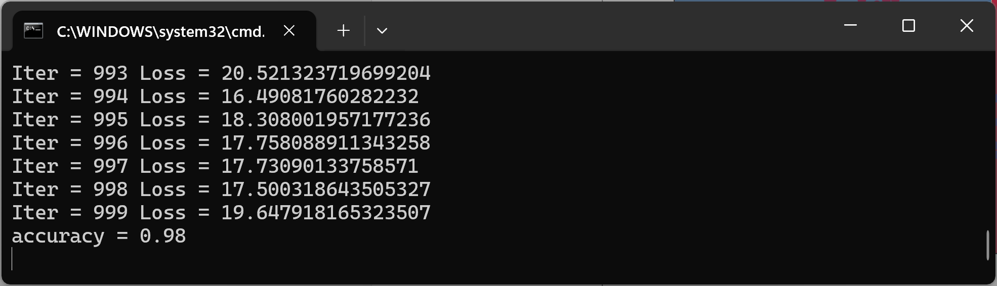
Exercise 3: Set the number of neurons in the hidden layer of the network to be 30. Train the network. Take a screenshot of the figure for submission. Answer the following question: based on the figure, is this model overfitting, underfitting or just right for the data? Hint: the code output should look similar to what is shown below.
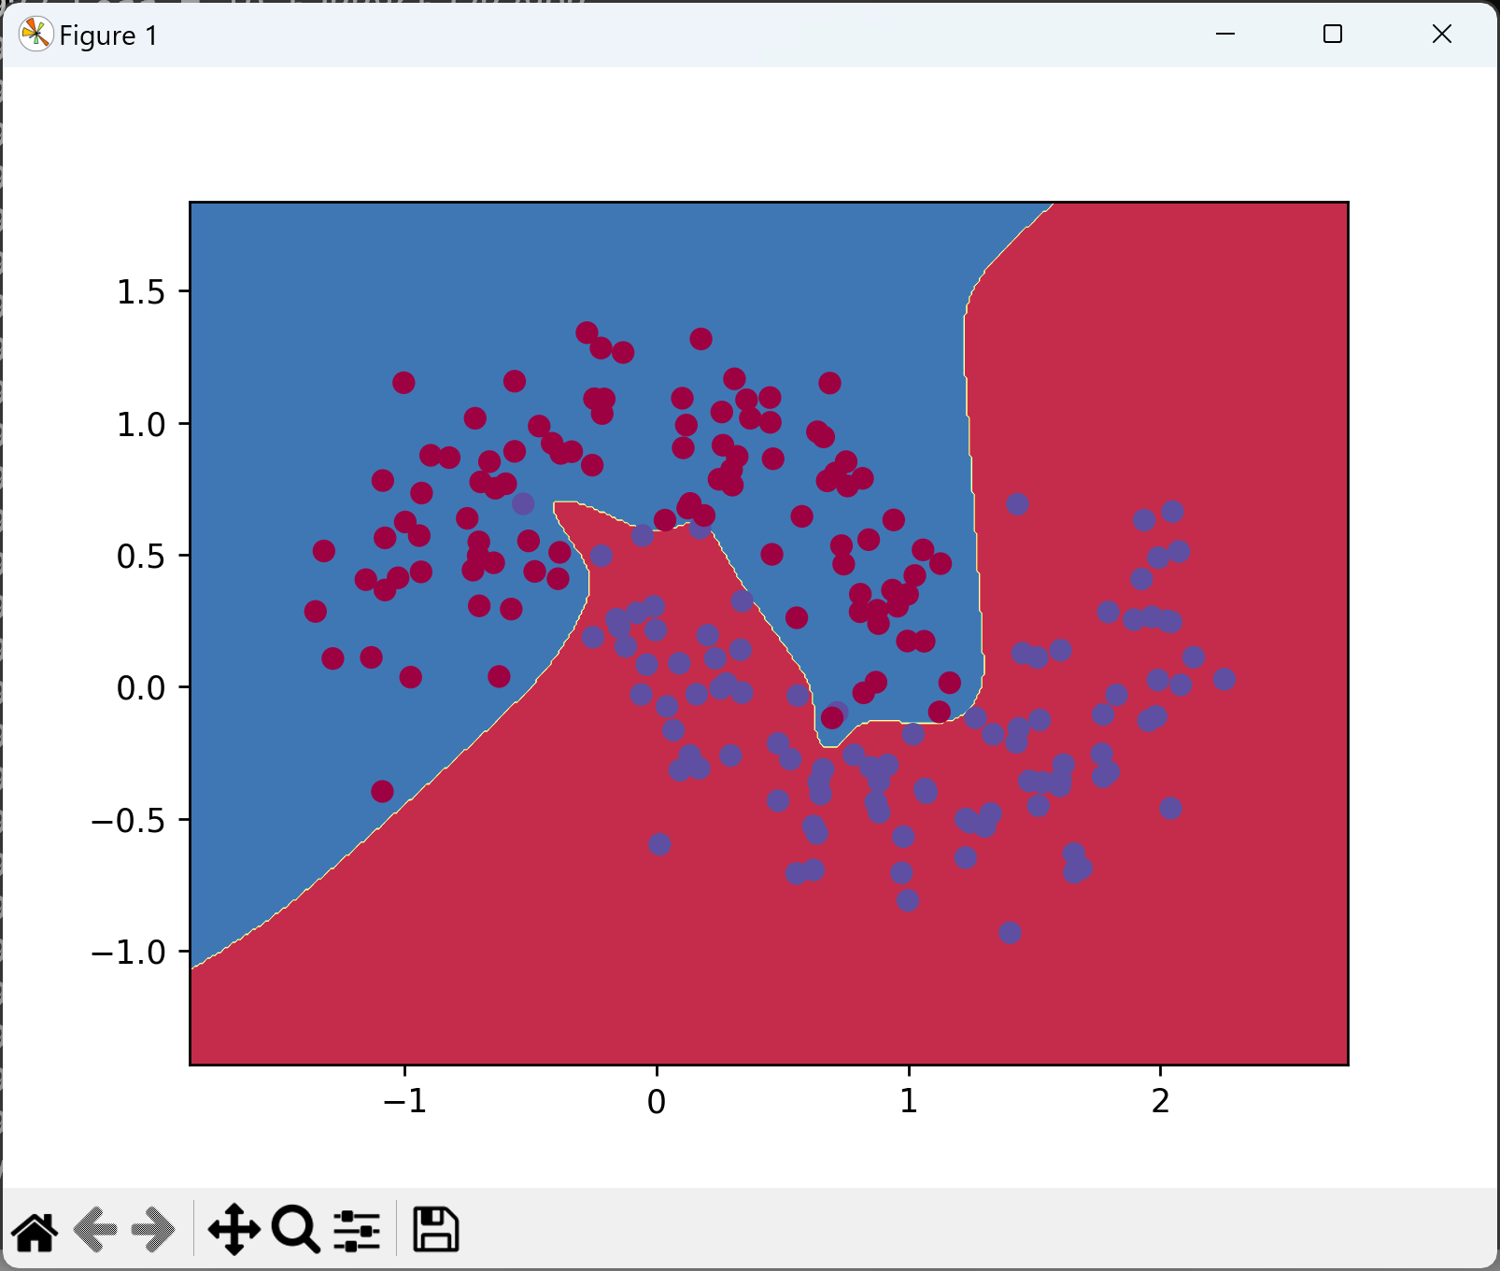
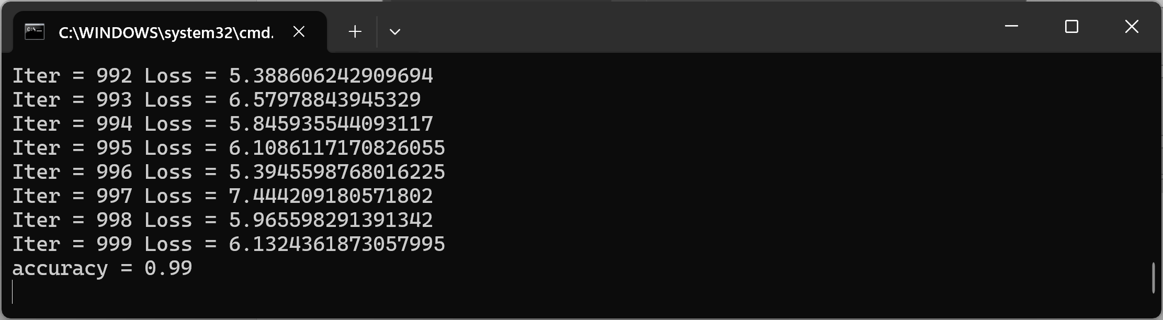

Exercise 4: In the previous exercises we did not reach 100% training accuracy. Train the network for 5000 epochs with 30 neurons in the hidden layer. Take a screenshot of the figure for submission. Answer the following question: based on the figure, is this model overfitting, underfitting or just right for the data? Hint: the code output should look similar to what is shown below.
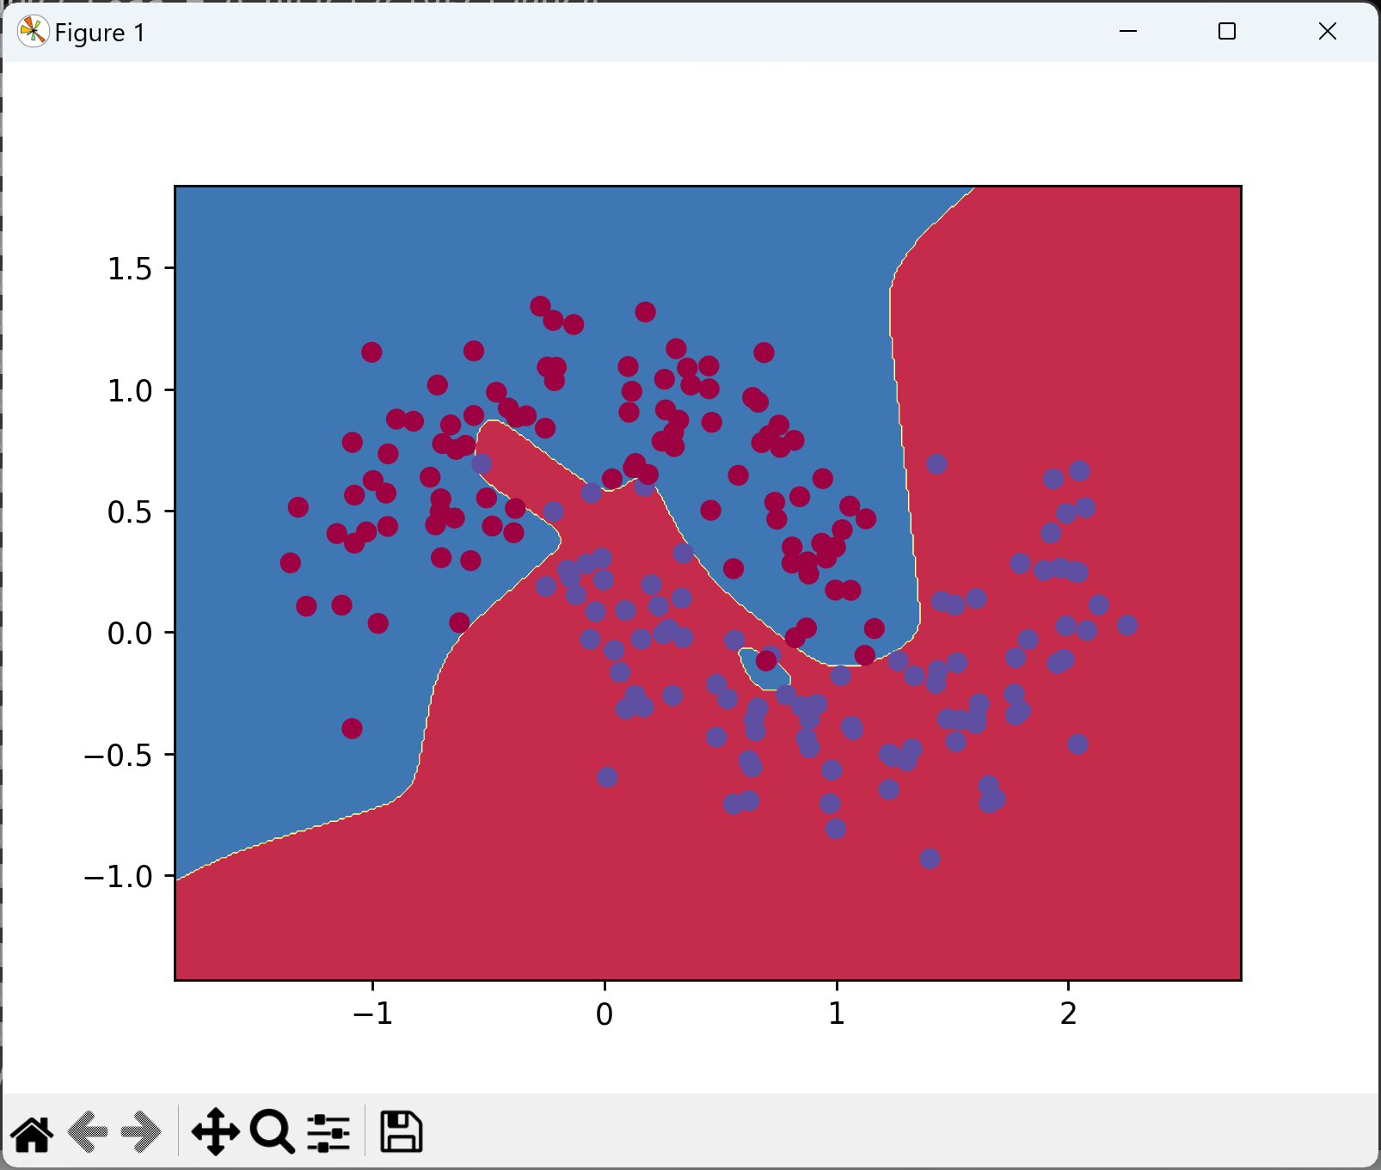
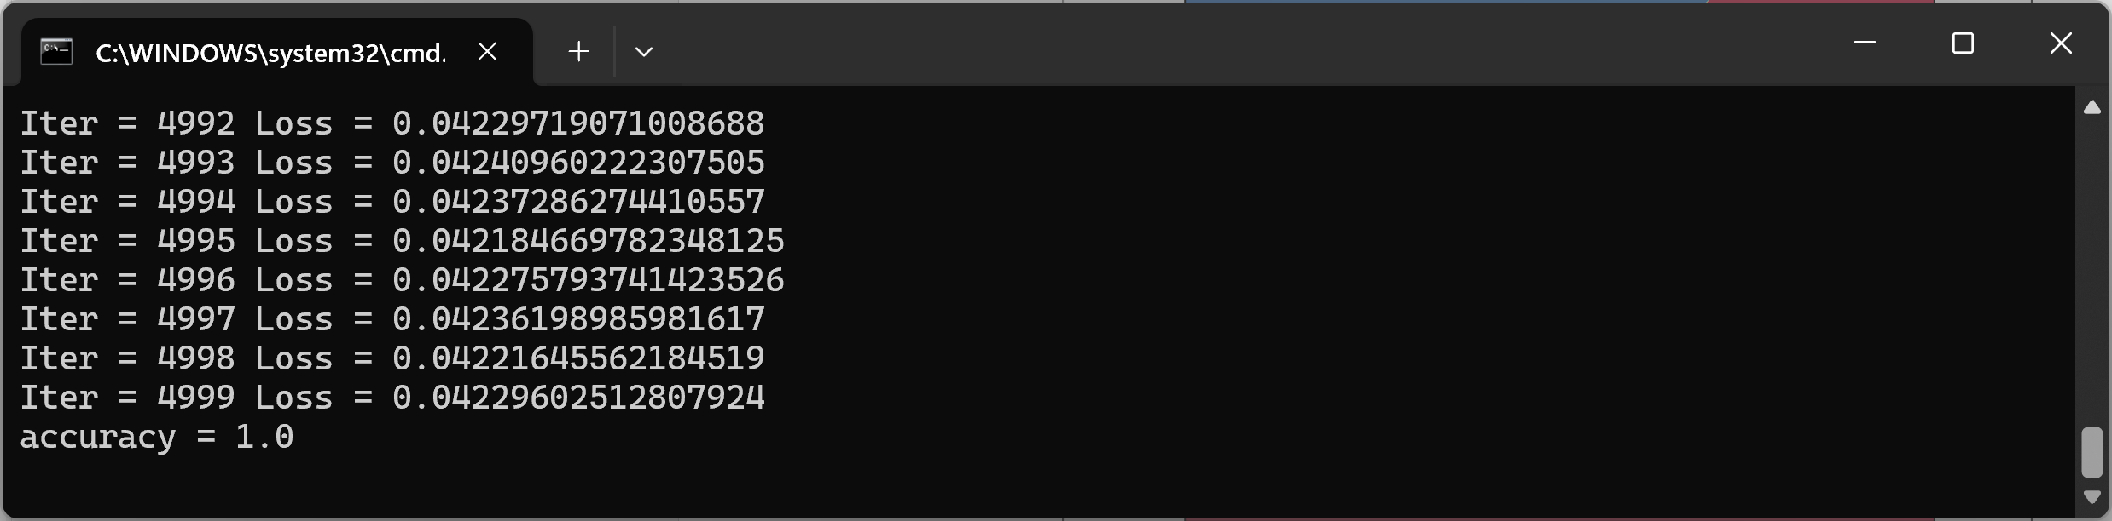

Deliverables
Submit the following two documents on Brightspace:
Deliverable #1: A screenshot of the output for each of the four exercises running on your machine. In this document also include an answer to each of the exercise questions about underfitting/overfitting.
Deliverable #2: A copy of your code (the .py files).

